|  |
| --- |
|  |

|  |
| --- |
| QUOTATION |
| Sights & Sounds  Vietnam | |
| Hanoi – Halong - Hue – Hoian - Saigon | |

|  |  |  |
| --- | --- | --- |
| Quotation for |  | Private Traveler |
| Duration |  | 11 Days |
| Destination |  | Vietnam |
| Tour Type |  | Private Leisure |

Itinerary

|  |  |  |
| --- | --- | --- |
| DAY 01 | Arrival inHanoi | (-, -, -) |

Welcome to Vietnam, the land of the ascending dragon! An 11 day adventure awaits for you to explore the sights and sounds of Vietnam.

You will be greeted at the airport by your English speaking guide and transferred to your hotel in the city center. Take some time to relax after your trip and freshen up. In the evening, we recommend stepping outside into the hustle and bustle of Hanoi City and exploring the vicinity of your hotel by yourself. See locals enjoy their hearty meals crouched on small plastic chairs and wonder at the motorbikes carrying immense weights around the city.

**Overnight in Hanoi**

|  |  |  |
| --- | --- | --- |
| DAY 02 | See the Sights of Hanoi City | (B, -, -) |

With a millennium-long history, Hanoi is a city of lakes, shaded boulevards and public parks dotted with French-style buildings and historical monuments. The city centre is an architectural museum piece, retaining the air of a quaint and peaceful provincial town, contrary to the fast-paced atmosphere of Saigon.

During today’s half-day city tour, you’ll see cultural and historical highlights, such as the One Pillar Pagoda designed to resemble a lotus blossom, Hoan Kiem Lake right in the heart of Hanoi and the Temple of Literature, the site of Vietnam’s first university dating back to 1070. One particular highlight this morning will be the exploration of Hanoi’s Old Quarter consisting of 36 Old Streets divided and named according to their craft guides in the past. This area is also the eternal soul of Hanoian cultural architecture, historic relics and religious center. We conclude our tour of the city with a visit to the old railway tracks that run through Hanoi’s centre. Enjoy some coffee along the tracks and don’t forget to take photos along the way.

|  |  |
| --- | --- |
| Image result for hanoi railway track wiki |  |

In the evening, you will be whisked away to an impressive outdoor venue just outside Hanoi, where you will enjoy a magnificent stage show called ‘The Quintessence of Tonkin”. Showcasing traditional elements of Vietnamese culture in a contemporary and innovative way, the Quintessence of Tonkin gives you a unique and memorable insight into the culture of the Red River Delta — the beating heart of northern Vietnam. Enjoy songs and dancing to traditional music with unexpected, modern twists.

**Overnight in Hanoi**

|  |  |  |
| --- | --- | --- |
| DAY 03 | Magnificent Views over Halong Bay | (B, L, D) |

|  |
| --- |
| http://upload.wikimedia.org/wikipedia/commons/4/43/Asia_Cruise_Junk_in_Halong_bay.JPG |

After a leisurely breakfast you leave Hanoi and head east toward the Vietnamese coast. In Halong Bay, one of the most magnificent scenic spots in all of Vietnam, you will go aboard a luxurious cruise shop that will take you through the picturesque bay. With almost 2,000 islets rising from the clear emerald waters, the Gulf of Tonkin is a must-see paradise.

Enjoy your afternoon crusing around the bay, exploring the waters by kayak or simply relaxing onboard the mighty cruise. Make sure to catch the breahtaking sunset over Halong Bay!

**Overnight on board**

|  |  |  |
| --- | --- | --- |
| DAY 04 | From Halong Bay to Imperial Hue | (B, -, -) |

Rise with the sun to enjoy the view over the bay once more before you enjoy breakfast and then get ready to leave for your next adventure. Disembark in the late morning and return to Hanoi. You will be taken straight to the airport to catch a flight South to the Imperial city of Hue.

In Hue, your English-speaking guide will greet you at the airport and take you to your hotel in the city centre. Enjoy the evening at your own leisure. We are happy to arrange a dinner or optional evening tours for you!

**Overnight in Hue**

|  |  |  |
| --- | --- | --- |
| DAY 05 | Imperial Sights of Hue | (B, L, -) |

Your day starts early with an 8 o’clock departure for Kim Long village. Embark on a leisurely bike ride around this village to immerse yourself into the greenery of a so-called “Garden City”. Slow down to discover Hue’s unique landscape architecture, learn more about he city’s philosophy of gardening and explore the village temple and handicraft workshops along the way.

A three-generation family welcomes you into their garden house and you are warmly invited to cook and enjoy an authentic home meal with the family. Afterwards you have the unique opportunity to meet a true master of calligraphy. He will show you the century-old art of writing and the old techniques used to create beautiful masterpieces. Feel free to try your hand at this craft and create souvenirs to decorate your home with. A short boat ride brings us back to Hue’s city center.

The afternoon is dedicated to exploring the wonders of the Imperial Palace in Hue. Citadel at the Imperial Palace. It was completed in 1833 and from here the emperors of the Nguyen Dynasty ruled Vietnam till 1945. Entering the citadel via a stone bridge you can see the Thai

Hoa Palace. The ostentatious columns supporting the roof are lacquered and inlaid with gold.

|  |
| --- |
|  |

|  |
| --- |
|  |

**Overnight in Hue**

|  |  |  |
| --- | --- | --- |
| DAY 06 | Hue – Danang - Hoian | (B, -, -) |

Transfer to the train station to take the train to Danang. Arrive in Danang train station. Transfer to Hoian by car

Visit PRECIOUS HERITAGE GALLERY MUSEUM – Rehahn Photographer

Description details here

<http://www.rehahnphotographer.com/gallery-hoi-an-vietnam/>

**Evening PALAO Show (Lune Performing Center Hoi An)**

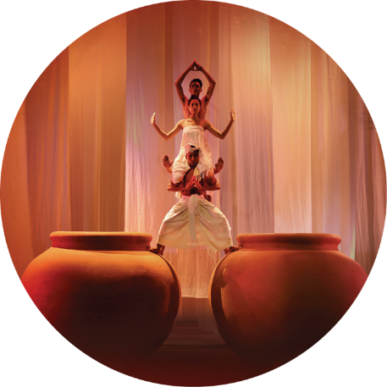Experience the richness of Vietnamese culture with this spectacular hour-long show mixing the acrobatics of contemporary circus with the theatricality of the stage, the musicality of a moon string instrument, and, above all, poetry. The leading visuals of the show – the chastity of bamboo, the basket boat – reflect the spirit of the Vietnamese people and their heritage.

There is no script, no climax and no sequence. During the hour-long show, the audience is gently introduced to many different tones of emotion of Vietnamese life, capturing in it the Vietnamese dream of life, love, and everything in between

**Overnight in Hoian**

|  |  |  |
| --- | --- | --- |
| DAY 07 | Hoian | (B, -, -) |

Morning Hoi An's old quarter with History Museum, Chinese Assembly Hall, Japanese covered bridge and historic old house (walking tour)

We start the walking tour at the Culture and History Museum where you will learn about the history of this charming and peaceful town before you walk around the small market. Walk along the main street to the Chinese Assembly Hall of Fujien Chinese community. The hall, built in 1697, has been used as the worshipping place to dedicate to Thien Hau (the Goddess of the Sea or Holy Mother). Continue to the river bank along narrow streets - on both sides are old houses transformed into beautifully decorated shops with colorful lanterns in different shapes. Next we'll stop to see the Japanese covered bridge built in the early 17th century by Japanese traders who settled in the town.

The special pagoda-shaped bridge is now the official symbol of Hoi An. We finish with a visit to a historic old house of this UNESCO-recognized town.

**In the afternoon taking the Sunset Paddle Excursion in Hoian**

The river system and the countryside of Hoi An offers a million charming moments, providing you with stunning photo opportunities. Join us as we paddle our way down the Ancient Town while the sun sets! This is a great way to see the lantern town during the golden hour.

**Highlights:**

* A closer look to Hoi An’s river ecosystem and local life
* Capture a stunning view of ancient architecture in golden rays.

**Tour program:**

15.00/16.00 – Pick up from your hotel and have a quick transfer to our kayak station in Cam Thanh. After a briefing on paddle safety and the area you will be kayaking, we’ll set off to paddle along the cocopalm forest and local villages and up to the Lantern Town. Connect with nature, immerse ourselves in life on the river and enjoy amazing landscapes as we paddle into the sunset.

**Note:** This tour closes in Nov - Dec - Jan – Feb

**Itinerary:**

15.00/16.00 – Pick up from hotel, transfer to Cam Thanh. Kayak paddle along

cocopalm forest and then head to Ancient town.

18.00 /19.00 – Disembark from the main pier (near Ancient town), refreshment at a local café then get transfer back to hotel

|  |
| --- |
|  |

|  |
| --- |
|  |

**Overnight in Hoian**

|  |  |  |
| --- | --- | --- |
| DAY 08 | Hoian – Danang - Saigon | (B, -, -) |

After breakfast at hotel, you will be transferred to Danang airport for your flight to Saigon

**Overnight in Saigon**

|  |  |  |
| --- | --- | --- |
| DAY 9 | Cu Chi Tunnels – Army Veteran Visit | (B, -, -) |

|  |
| --- |
| http://media.sdreader.com/img/photos/2012/11/01/Cu_Chi_Tunnels_Vietnam_t658.jpg?ff95ca2b4c25d2d6ff3bfb257febf11d604414e5 |

**Cu Chi Tunnel** Complex – a national symbol of Vietnamese courage!

Cu Chi was an important base during the American War, because of its strategic location. The Vietcong built a 200km long network of tunnels connecting command posts, hospitals, shelter and weapon factories.

Dug out of hard laterite by hand tools without the use of cement, the tunnel system stretched from Saigon to the Cambodian border and was three levels deep.

Today, the remaining tunnels have become a major tourist attraction, giving visitors a unique experience and a feeling of what underground life in the war must have been like.

Return to Saigon. Continue visiting **an Army Veteran** at his house to hear some stories about his experience during the War

**Dinner on Bonsai Cruise**

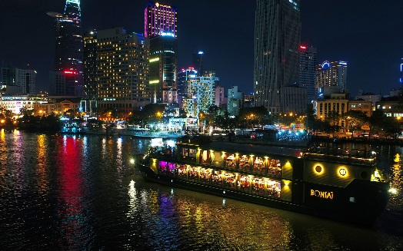

Step aboard and be introduced to a world that honours ancient Saigon, times long ago forgotten. From the moment you board this grand beauty of the river you will be swept away and amazed at our attention to detail and service.

**Overnight in Saigon**

|  |  |  |
| --- | --- | --- |
| DAY 10 | Half-day city tour – Truc Mai house | (B, -, -) |

Enjoy **a half - day tour** through colonial Saigon.

The **OLD SAIGON POST OFFICE** is the largest of Vietnam's post offices; it was built from 1886 to 1891 by the great architect Gustave Eiffel. The same architect who gave his name to the Eiffel tower in Paris. The post office is large, open, and with a big picture of Ho Chi Minh overlooking the proceedings. This unique place will remind you of being in a train station.

The **OPERA HOUSE** is another example for French colonial architecture in Saigon. It was built in 1897 by the famous architect Ferret Eugene and the magnificent facade decor was renovated in 1998.

**NOTRE DAME CATHEDRA**L ***(close for renovation until 2019 TBA, but still possible to admire its beauty from outside)*** is one of the landmarks among the impressive avenues and open spaces north of Dong Khoi. The huge red-brick edifice with twin spires is placed between two streams of traffic and is a clear reminder that the French once ruled this city. Inside, the decor is relatively austere, but the church gets very full and very lively during services. This peaceful place is perfect for quiet contemplation. Sunday Mass is held at 9.30am.

The former **PRESIDENTIAL PALACE** is now renamed the Reunification Hall. It is one of the most interesting places to visit in Ho Chi Minh City. This building remains almost exactly as it was on the morning of 30th April 1975 when the Saigon regime surrendered to the victorious liberation forces and the country was reunified for the first time since 1945. Included on the tour are visits to conference rooms, the Presidential Receiving Room, basement tunnels and war room, telecommunications centre and the residential area of the former president.

The **OLD CITY HALL** is a stroll down from Dong Khoi Street and is a colonial building dated back to 1906. The city's best-known market, where you can buy anything from fresh fruit and flowers to the latest imported electronics and cosmetics is located at one of the key intersections in the city centre.

Inside is a tightly organized grid of aisles, arranged according to product. Clothes, shoes and fabric dominate the front, before giving over to kitchenware, cooked food, fresh vegetables and a somewhat alarming display of seafood and meat, some of it still alive. There is plenty for the visitor to buy, but the main attraction is the way in which the bustling market is still very much part of the city's life and economy.

|  |
| --- |
|  |

|  |
| --- |
|  |

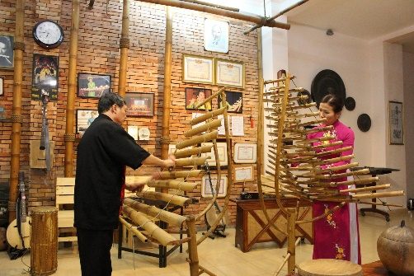Afternoon arrive at **Truc Mai House** (at a pre-arranged time) where you will be welcomed with a cup of tea.  You are at the home of Mrs. Tuyet Mai and Mr. Dinh Linh, who have both studied at the Vietnam National Academy of Music. They are long time experts of traditional music and have been representatives of Vietnam performing in countries around the world. Their house is a warm, inviting space where they perform sharing their passion entertaining guests with traditional Vietnamese music.  Vietnamese musical instruments, though very simple, are quite interesting and attractive to overseas people for their sound and unique characteristics. Enjoy a short show! After the show, you’ll have the opportunity to play any and all of the many traditional instruments yourself amidst kind coaching and laughter from your hosts!

**In the early evening Vespa After Dark**

Part night excursion, part street food adventure. Pick up guests at hotel and first stop is to Café zoom to "watch the world goes by" (quoted by The Lonely Planet) and enjoy cocktail and appetizer (inclusive) before adventuring into favorite local eating spot. Guests experience the nightlife of Saigon the way locals do, all from the back of a vintage Vespa. The tour will start with a ride to part Chinatown and then heading to District 4 through busy streets and alleys to see the night life of locals and enjoy street sea- food and cold drinks, places that foreigner won't be found.

Leaving

|  |
| --- |
| Saigon After Dark Bike Tour |

district 4 to district 3 the tour pass through downtown district 1 to take in the sights on the way to Banh Xeo, specialty of Saigon and southern food with the locals. Then the tour will continue to a hidden Vietnamese-style coffee shop to have a taste of Vietnamese music (live) as a local. After this the tour will bring guest to a lively music venue to enjoy the drinks with live music. Guests ride pillion behind our drivers.

**Time:** 6:00-10pm (4 hours)

**Includes**: Vespas, drivers, English speaking tour guide, dinners (2 stops), local music venues and café (3 stops), at least one drink at each stop.

|  |  |  |
| --- | --- | --- |
| DAY 11 | Farewell Saigon | (B, -, -) |

Enjoy peaceful breakfast once more before you get ready for your departure from Vietnam later today. Your guide will accompany you to Saigon airport where you bid farewell the Vietnam and the sights and sounds this fascinating country has to offer. We wish you a safe onward journey and look forward to welcoming you again in Vietnam.

Tam biet – Goodbye!

**\*\*Small program changes might occur due to unexpected flight schedule changes, traffic and weather conditions\*\***

|  |
| --- |
| End of services |